**SYDE 675 Assignment1**

Student ID:20705271

Name: Xin Chen

**Case 1**

Because the covariance of Class 1 and Class 2 are equal, the MED, GED classification boundaries are the same.

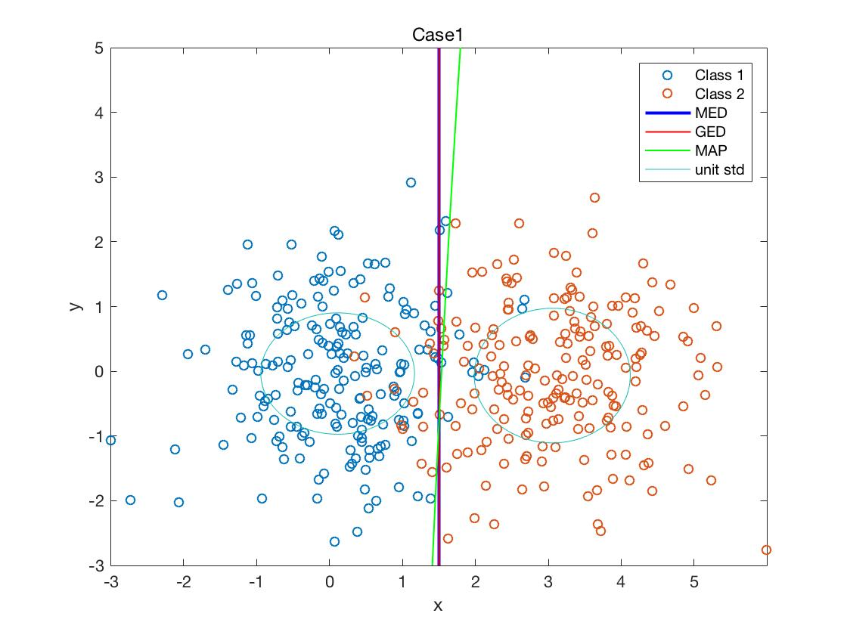

**Case 2**

Because the covariance of Class 1 and Class 2 are the same, the GED and MAP classification boundaries are very close.

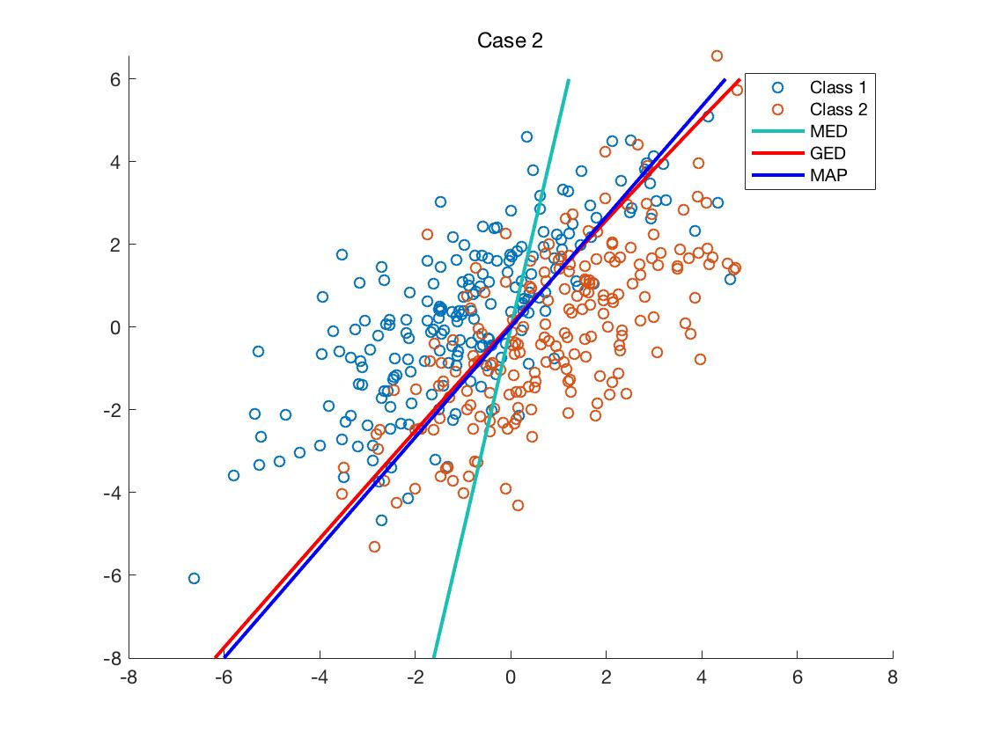

**Case 3**

Because the covariance and the mean of Class 1 and Class 2 are different, MED, GED and MAP classification boundaries are different.

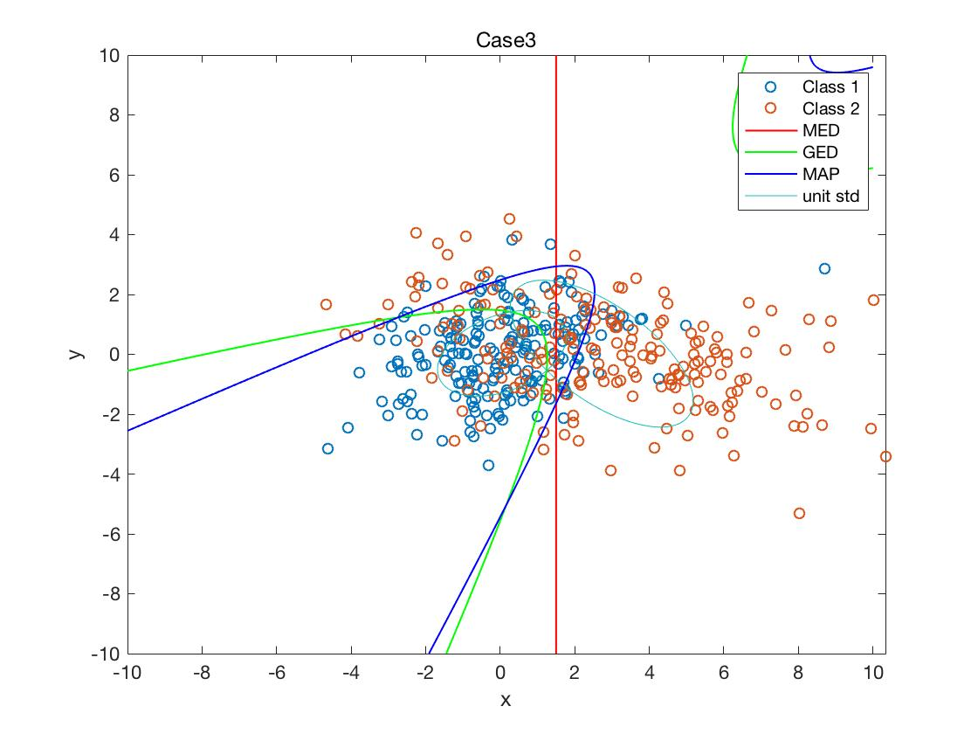

**Case 4**

Because the generated MED and GED are different in Case 4, we can find that covariance and the mean of Class 1 and Class 2 are different.

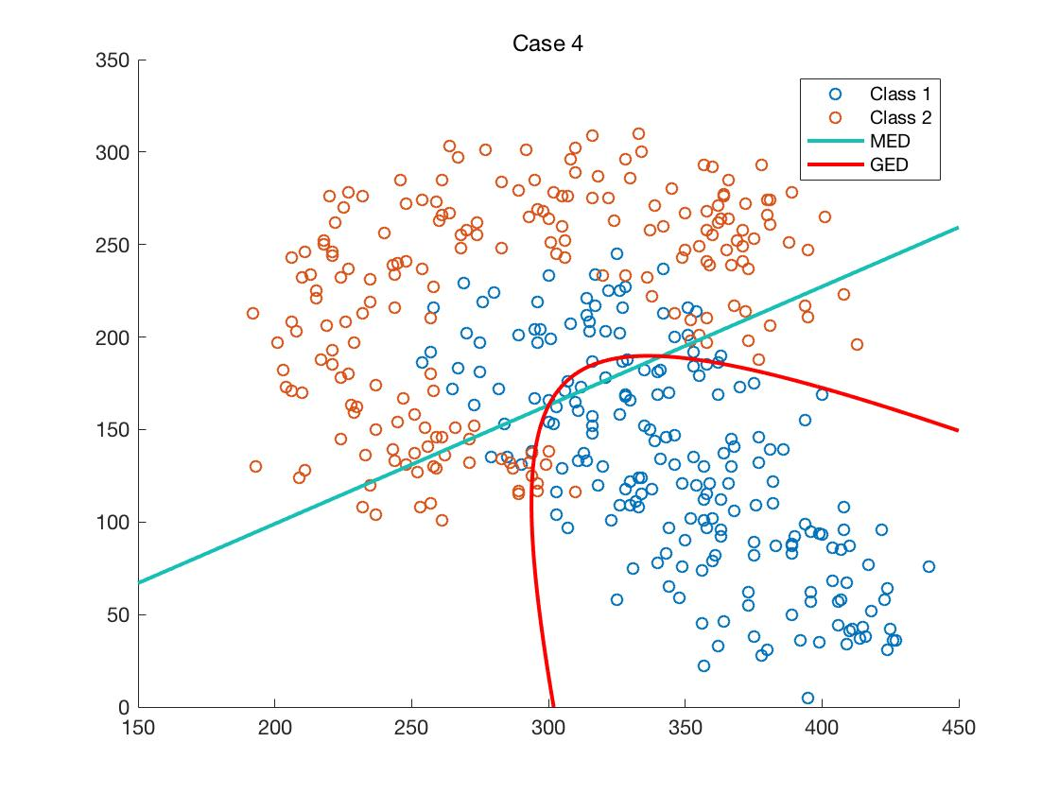

**Case 3-NN/3NN/5NN**

It is clear that contour of NN changed a lot and it looks more complicated, while for 3NN and 5NN, the line will be gentler and easy. This is because it will be influenced by only one nearest point in NN case, which means that for NN plot it is outlier sensitive, but with K increasing, the sensitivity will decrease. As a result, the lines in 3NN and 5NN will be simpler and more blur.

